GATE 0 - PROJECT SYNOPSIS
Themes 1-5 | System / Tool / Engine based Mini Projects

Expected length: about 4 pages + cover page
Team No. | 14
Theme No. | 3
Project Title | Adaptive Video Streaming and Buffer Management
Guide Name | Amit Kachavimath
Team Members | 1.Divya Kumari  2.Akshay Bhat  3.Renuka Kagadal  4.B Bhagyashree

Student Preparation Instruction
This synopsis is intended to demonstrate the team's own understanding of the proposed project. Students should study the project, discuss within the team, consult relevant textbooks/technical resources, and prepare the content in their own words. AI tools shall not be used to generate the contents of this document.
At Gate 0, do NOT finalize: detailed functional/non-functional requirements, architecture/modules, algorithms/data structures, APIs, technology stack, alternate designs, detailed KPIs or test cases.
1. Background & Motivation
Briefly describe the proposed system/tool/engine, its purpose, broad functionalities/computational capabilities, and why developing it is technically meaningful as a Mini Project. Highlight opportunities to apply and integrate foundational Computer Science concepts.
Video streaming depends on the network speed and on how many clients use the same server. Network speed can change often, and many clients may watch at the same time. This can cause buffering, delays, and frequent changes in video quality.
Our proposed Adaptive Video Streaming and Buffer Management Engine will serve multiple clients from one server, with caching on the server. It will adjust each client’s video quality and manage its buffer based on the current network condition to provide smooth and continuous playback.
The project is technically meaningful because it combines Computer Networks, Operating Systems, Data Structures, Algorithms, DBMS, and Software Engineering concepts in one practical system.

2. Project Objectives
State 3-5 broad engineering objectives. Describe what the team intends to develop or study. Do not prematurely prescribe architecture, algorithms, data structures, APIs or implementation mechanisms.
1. To understand how changing network speed and many clients affect video streaming performance._____________________________________________________________________________
2. To study the balance between video quality, smooth playback, and network use. _______________________________________________________________________________
3. To develop a system where each client picks its video quality automatically without manual help _______________________________________________________________________________
4. To improve the reliability and efficiency of video delivery by handling many client requests together and using server-side caching. _______________________________________________________________________________
5. To assess system behavior for many clients across diverse network conditions using relevant quality-of-experience metrics. _____________________________________________________________________________________________

FOUNDATION COURSE INTEGRATION & CONCEPTUAL VIEW
Gate 0 - Themes 1-5

3. Foundation Course Integration
Identify at least three foundational courses that are expected to contribute meaningful technical depth. Mention only broad concepts/areas at this stage.
Sl. No. | Foundation Course | Broad Concepts / Areas Expected to be Applied | Role
1 | Computer Networks | Protocols (TCP/HTTP), socket programming, packets, bandwidth, delay, throughput, congestion and flow control | Dominant
2 | Operating Systems | Threads and processes to serve many clients, synchronization (locks), socket handling, memory and cache | Dominant
3 | Data Structures & Algorithms | Queues (buffer), hash tables (cache lookup), heaps/priority queues (request order), moving average (speed estimate) | Dominant
4 | DBMS | Storing logs, test results and cache data | Supporting
5 | Software engineering | Client-server design, requirements, use cases and test planning | Supporting
6. | Discrete Mathematical Structures | Graph theory (network basics), probability (traffic and sampling) | Supporting

4. Conceptual Workflow / System View
Draw one high-level block/workflow diagram showing the broad functional flow or major interactions in the proposed artefact. Keep it conceptual; detailed architecture, finalized modules, algorithms, data structures, APIs and technologies belong to later stages.
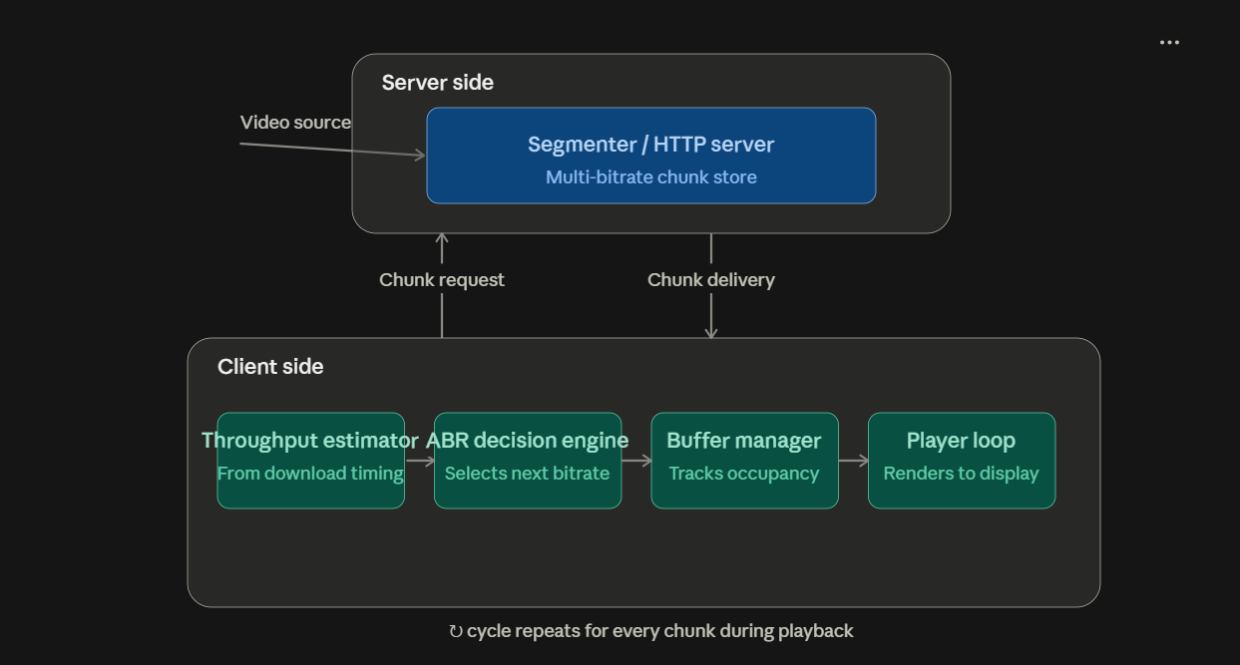

SCOPE & FEASIBILITY
Gate 0 - Themes 1-5

5. Broad Project Scope
Define the tentative technical boundary of the project. Detailed requirements will be derived later in S1.
5.1 Broadly In Scope
Broad In-Scope Item
● Segmenting a video into chunks at multiple bitrates
● HTTP-based chunk delivery from a server to multiple clients
● Handling many client requests at the same time
● Server-side caching of chunks
● A client-side adaptive bitrate (ABR) decision algorithm
● Playback buffer management
● Throughput estimation from chunk-download measurements

5.2 Out of Scope
# | Out-of-Scope Item | Reason
1 | Real video encoding/transcoding pipelines | The project focuses on adaptive quality selection, segment scheduling, and buffer management, rather than performing computationally intensive video encoding or transcoding. Pre-generated video segments at different quality levels will be used as inputs so that the system can concentrate on streaming decisions and performance.
2 | DRM | DRM requires secure content protection, encryption, license management, and integration with platform-specific systems such as Widevine, PlayReady, or FairPlay. These mechanisms are outside the project's main focus, which is the management and delivery of video segments under changing network conditions.
3 | Live streaming(video-on-demand only) | Live streaming requires additional mechanisms such as real-time encoding, low-latency segment generation, live manifests, synchronization, and handling of continuously arriving content. This project uses pre-existing video content so that the system can focus on adaptive streaming, buffering, scheduling, and performance analysis.

6. Feasibility & Constraints
Briefly assess whether the proposed scope is achievable as a 3-credit Mini Project. Identify required resources, prerequisite knowledge and major constraints. Existing libraries/tools may support peripheral functionality but should not completely hide the core mechanisms students are expected to design, implement and study.
Feasibility within 3-credit scope | - Feasibility: Feasible within the defined project scope.  - Core mechanisms: HTTP-based chunk segmentation and delivery to multiple clients, with caching on the server.  - Throughput: Estimate network throughput to understand available bandwidth.  - ABR: Dynamically select the appropriate video bitrate based on network conditions.  - Buffer management: Maintain a playback buffer on the client side to reduce rebuffering.  - Testing environment: Use a controlled client-server setup with several clients and pre-segmented test videos.  - Network conditions: Simulate variable bandwidth conditions for controlled experiments.  - Infrastructure: Does not require real-time video encoding or live-streaming infrastructure.
Required computing / resources | - Computer: Sufficient CPU, RAM, and storage to run the server and several clients.  - Programming environment: Socket/HTTP programming environment with suitable networking libraries.  - Test videos: Pre-segmented videos available in multiple bitrates/quality levels.  - Network simulation: A mechanism to simulate or throttle bandwidth over time using bandwidth traces.  - Performance logging: Lightweight file storage or a simple database.  - Metrics recorded: Rebuffering ratio, bitrate/quality switches, and other streaming performance metrics.
Prerequisite knowledge | - Computer Networks: TCP/UDP/HTTP protocols, socket programming, and concepts such as congestion and flow control are used for client-server communication and handling changing network conditions.  - Operating Systems: Threads and concurrent connection handling are used to serve many clients, and synchronization (locks) keeps shared data such as the cache safe. Socket lifecycle is also used.  - DSA: Queues and heaps/priority queues are used for playback buffering and request scheduling, and hash tables help in fast cache lookup.  - Software Engineering: Client-server architecture, modular design, requirements analysis, testing, and integration are used to develop and validate the streaming system.  - DBMS: Performance logs, test results and cache data such as buffer level, bitrate changes, rebuffering and throughput can be stored for analysis.  - Discrete Mathematics: Graph theory provides basic intuition for network topology/routing, while probability can support analysis of variable traffic and throughput.
Major constraints / limitations | - Network Simulation Limitation: Simulated bandwidth traces cannot represent every real-world network condition, such as packet loss, jitter, and actual network congestion.  - Streaming Type: The project is limited to Video-on-Demand (VoD) and does not include live streaming or DRM.  - Video Processing: No real-time video encoding or transcoding pipeline is developed; testing therefore uses pre-segmented sample videos.  - Project Time: Due to the 3-credit project timeframe, the scope is limited to implementing one ABR algorithm and evaluating it using a defined test trace with a limited number of clients.  - Study Scope: The project focuses on controlled evaluation rather than a broad comparison of multiple ABR algorithms or real-world network environments.
Use of existing libraries / tools | - Standard Libraries: Standard networking/HTTP libraries may be used for basic transport and communication.  - Video Preparation: Existing tools may be used to pre-segment sample videos into chunks.  - Throughput Estimation: The team must design and implement the method for estimating network throughput.  - ABR Algorithm: The adaptive bitrate (ABR) decision algorithm must be developed and implemented by the team.  - Playback Buffer Management: The team must design and implement the client-side playback buffer management mechanism.  - Server Caching and Multi-client Handling: The team must design and implement the server-side cache and the handling of many client requests together.  - Evaluation: The core mechanisms must be tested and evaluated by the team using the defined network conditions and performance metrics.  - No Existing ABR Library: An existing ABR library cannot be used to provide the core quality-selection or buffer-management logic.
Overall feasibility | Feasible

INITIAL PROJECT RISKS & FACULTY REVIEW
Gate 0 - Themes 1-5

7. Initial Project Risks
Identify 2-3 major risks that may affect completion of the project and briefly state how the team plans to address them. These are initial risks and may be revised as the project evolves.
Sl. No. | Possible Risk | How will you address it?
1 | Integration complexity: Integrating adaptive quality selection, buffer management, server caching and handling many clients together may cause unexpected issues. | Use a modular design, develop and test each module separately, then test together step by step, starting with one client and then adding more clients.
2 | Inaccurate network simulation: Simulated bandwidth, latency and packet loss may not represent all real-world network conditions, affecting the validity of performance results. | Test using multiple controlled network profiles and clearly define the limits and assumptions of the simulation.
3 | Scope creep and time delays: Adding extra features or spending too much time on individual modules may affect completion within the 15-week timeline. | Freeze the core scope, prioritize adaptive quality, buffer management, multi-client handling, caching and evaluation, track milestones regularly, and keep buffer time for integration and testing.
. Gate 0 - Faculty Review
☐ Technical motivation and objectives are clear.
☐ At least three foundation courses show potential for meaningful technical depth.
☐ Conceptual workflow/system view clearly communicates the proposed artefact.
☐ Broad scope is appropriate for a 3-credit Mini Project.
☐ Core mechanisms can be designed/implemented rather than fully hidden by ready-made tools.
☐ Feasibility, constraints and initial risks are reasonably identified.
Decision: ☐ Approved ☐ Approved with Modifications ☐ Resubmit
Faculty Remarks:
________________________________________________________________________________
________________________________________________________________________________
________________________________________________________________________________
Guide Signature: ____________________________ Date: __________________

